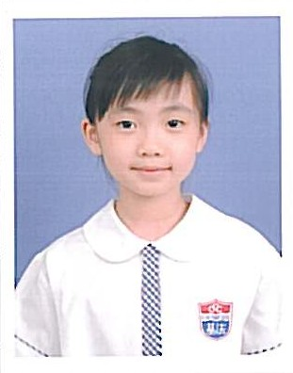
P.3A
Chan Hei Wai
Winner of the class

Lost in the Forest
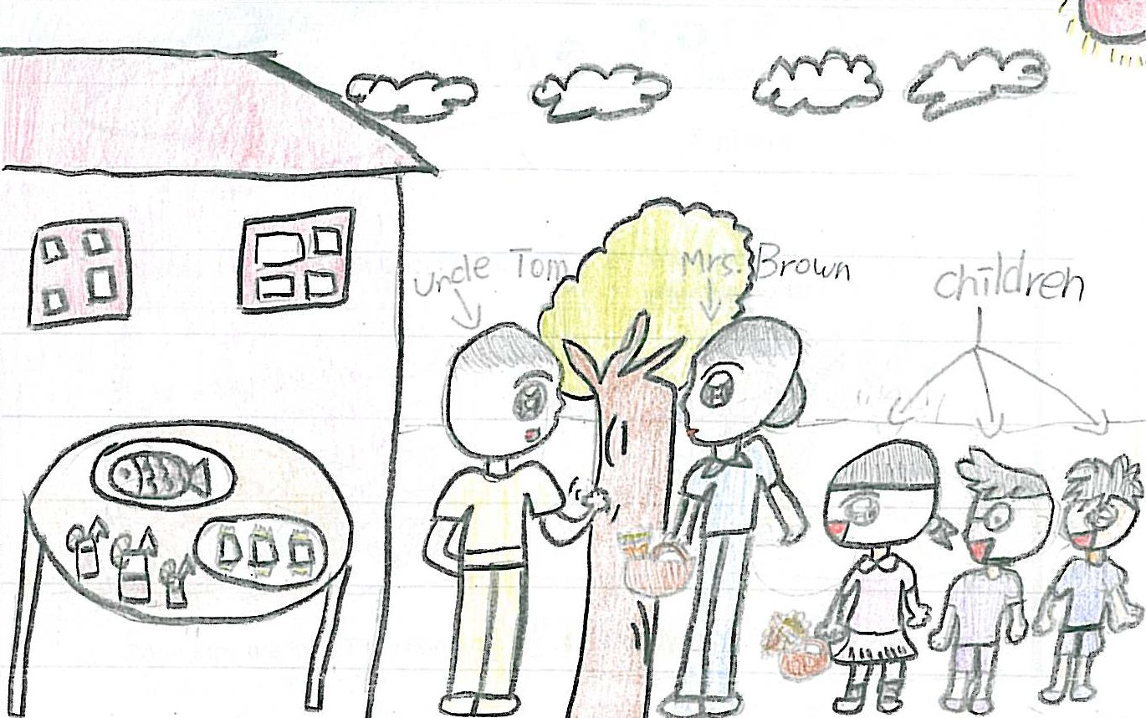
The children say “We are lost. We cannot find Uncle Tom’s house! Do you know where Uncle is?” Mrs. Brown says “Don’t worry! I live next to Uncle Tom’s house. You can follow me.” Then they walk with Mrs. Brown through the forest.
On the way to Uncle Tom’s house, they pick a lot of beautiful flowers and fresh fruits. Soon they reach the house and meet Uncle Tom. Uncle Tom welcomes the children with a table of delicious food. The children thank Mrs. Brown for her help and invite her to join their party. They give the flowers and fruits to Uncle Tom and Mrs. Brown. They then play games and enjoy the food. They are very happy.
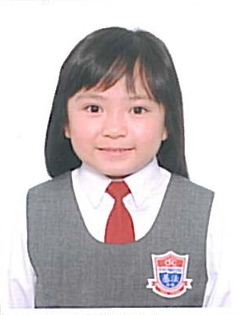
P.3B
Chu Wing Yan, Melody
Winner of the class
Primary 1-2
Merit
Primary 1-2
Merit
Primary 3-4
Champion
Lost in the Forest
The Children are happy. They follow Mrs Brown to find Uncle Tom. When they are walking, the children are surprised to see that there is a tail at the back of Mrs Brown. They think Mrs Brown is a wolf who pretends as a kind lady to cheat them. Wendy is very scared and she wants to cry but Billy stops her secretly.
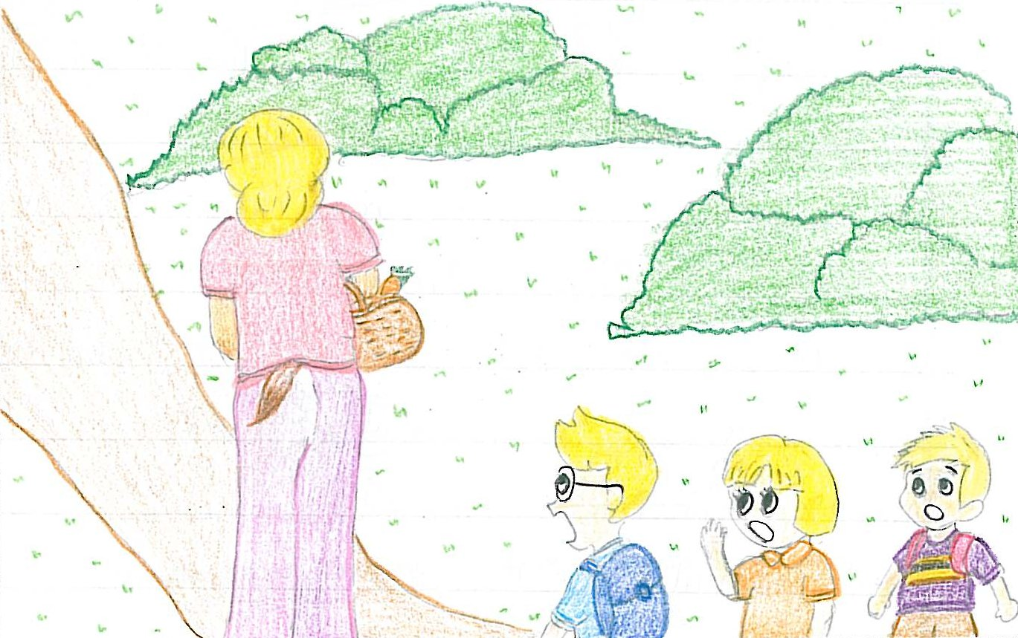
Then Billy says, “I hope Little Redhood is as lucky as we are.” Mrs Brown is curious to know and she asks Billy what he is talking about. Billy tells her that before meeting her, they meet Little Redhood who also gets lost in the forest when she is going to visit her grandmother. Mrs Brown is glad to hear this news. She says, “Oh! Where is she? I know her grandmother and I can help her too.”
Billy shows her the way and walks back together. When they walk near a cave, Billy tells Mrs Brown that Little Redhood is very tired and she takes a nap in the cave. When Mrs Brown enters the cave to find Little Redhood, the children push a big stone to block the entry of the cave. Mrs Brown finds that she is trapped and unable to get out of the cave. She cries loudly, “Help! Help!”
At this moment, Uncle Tom passes by and hears someone crying for help. He is very happy to see that the children are safe. Wendy tells him what happens. Uncle Tom says, “You are very clever and brave. Let’s go to my house to celebrate.” The children cheer loudly, “Yeah!”
Finally, they go to Uncle Tom’s house happily and leave Mrs Brown alone in the cave.
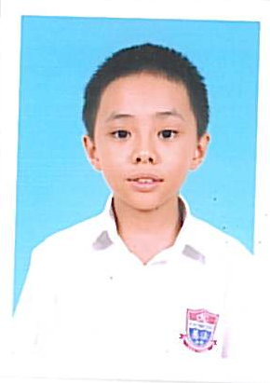
P.3C
Li Shing Chung, David
Winner of the class
Primary 3-4
Merit
Lost in the Forest
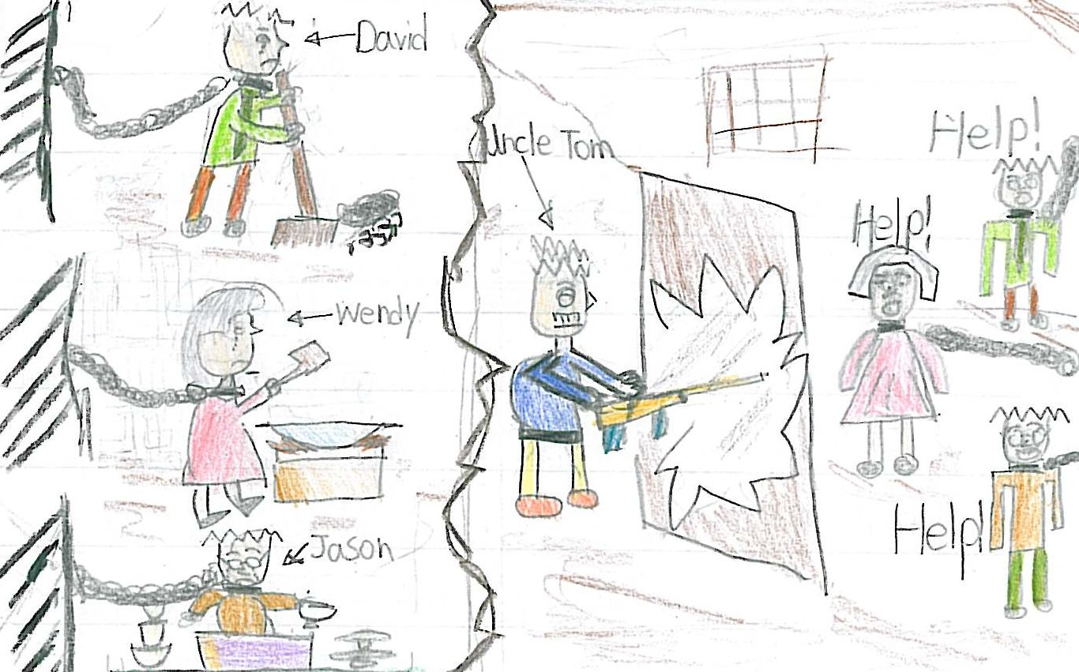
The children are very happy. They think they can go to Uncle Tom’s house.
“But Uncle Tom is not at home now,” the woman says. “He is hunting in the forest for two days. You can come home with me. I have a lot of good food in my house,” the children follow her.
Soon the moon shines in the sky. In the forest there is only wind blowing and sound of leaves. In the house there is a meal of pancakes, meat, milk and fruit on a table. The children are eating them. Soon after the meal they fall asleep on the table.
Early next morning the children wake up and find them locked with chains. They are crying. They know the woman is bad. She wants them to be slaves. “Get up, lazy children!” the woman screeches, “Wendy, cook something good for me. David, clean the living room. Jason, clean the kitchen.”
Day after day passes, the children are soon tired out because the woman makes them clean and scrub, and cook meals for her.
One day, the children hear some noise outside the house. They see a man with a long gun. It is Uncle Tom. “Help! Please help! Uncle Tom,” the children cry. “The bad woman traps us to be the slaves in the house.”
Uncle Tom breaks into the house and saves the children. He catches the bad woman to a police station. Police puts her in jail. The children are happy again.
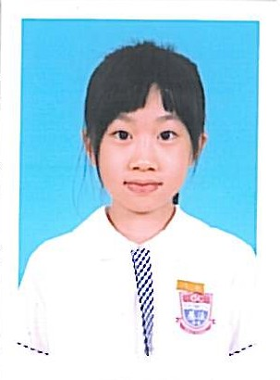
P.3D
Ip Cheuk Yan
Winner of the class
Primary 3-4
Merit
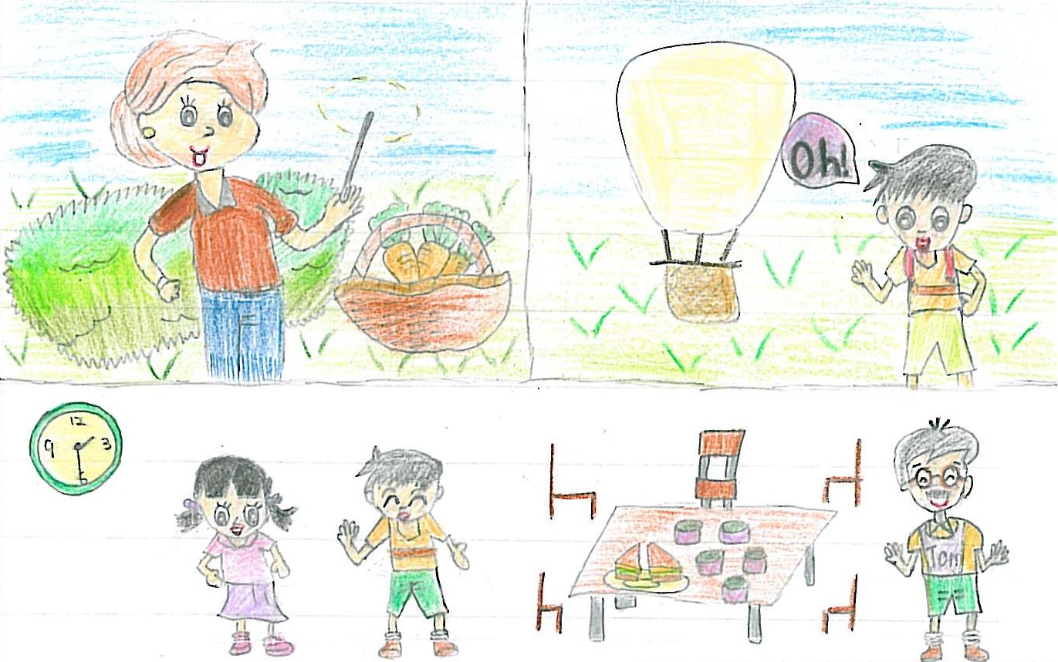
Lost in the Forest
The children told Mrs Brown that they were lost. Mrs Brown said, “I can bring you to Uncle Tom’s house. I am a witch. Do you want a wonderful trip?” “Yes, I do.” The children replied. Suddenly, Mrs Brown waved her magic wand over her basket. The basket changed into a hot- air balloon, “Oh, thank you!” cried the children. Now they were taking the hot-air balloon with Mrs Brown to Uncle Tom’s house. Uncle Tom was very happy when he saw the children. The children told Uncle Tom what happened in the forest. He thanked Mrs Brown and invited her to join the party.
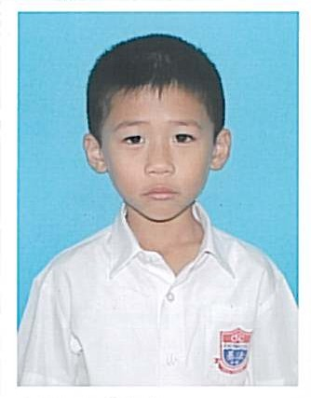
P.3E
Chan Cheuk Lok, Louis
Winner of the class

Lost in the Forest
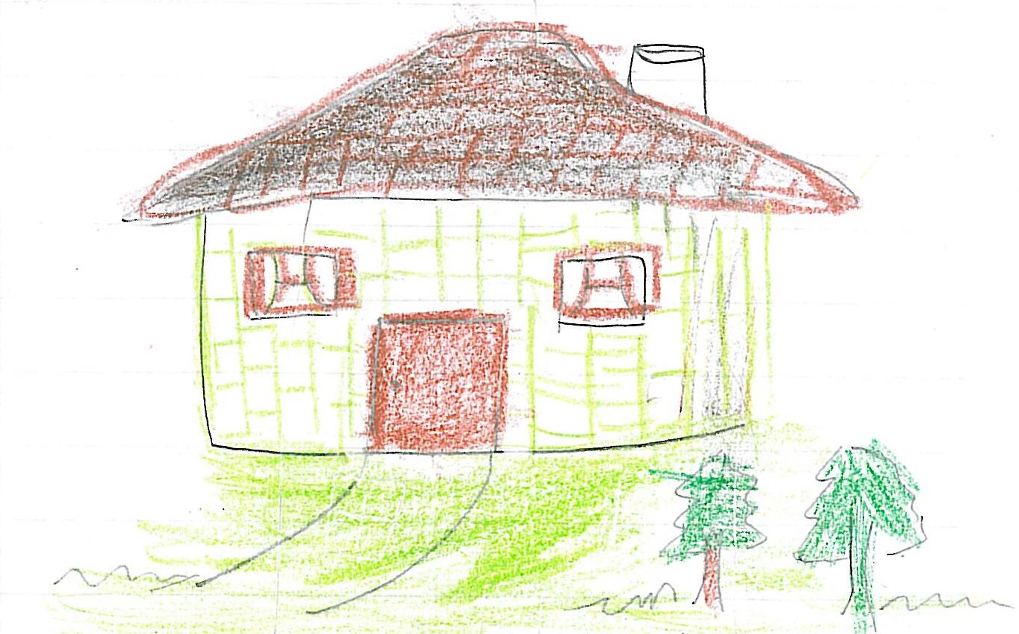
‘Mrs Brown, I’m Tim. They are Wendy and Ray. We’re going to visit Uncle Tom, but we are lost. Do you know where he lives?’ says Tim. ‘Sure. I know Uncle Tom. He is my friend. Don’t be afraid. I’ll bring you to his house,’ says Mrs Brown.
Then the children followed Mrs Brown. About ten minutes later, they saw a small house with a small garden in front of it. ‘Uncle Tom’s house is there,’ says Mrs Brown.
When they reached the house, a dog came out and barked at them. ‘I’m afraid of dogs,’ says Wendy with a shaking body. At this moment, Uncle Tom came out and says, ‘keep quiet, Lucky. They are my guests. Children, I’m waiting for you. Let’s have a big meal together.’
The children thanked Mrs Brown and said good bye to her.
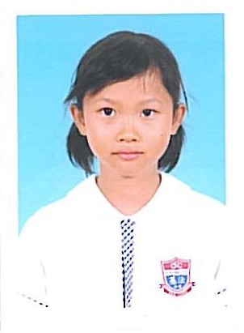
P.3F
Yeung Tsz Tung
Winner of the class

Lost in the Forest
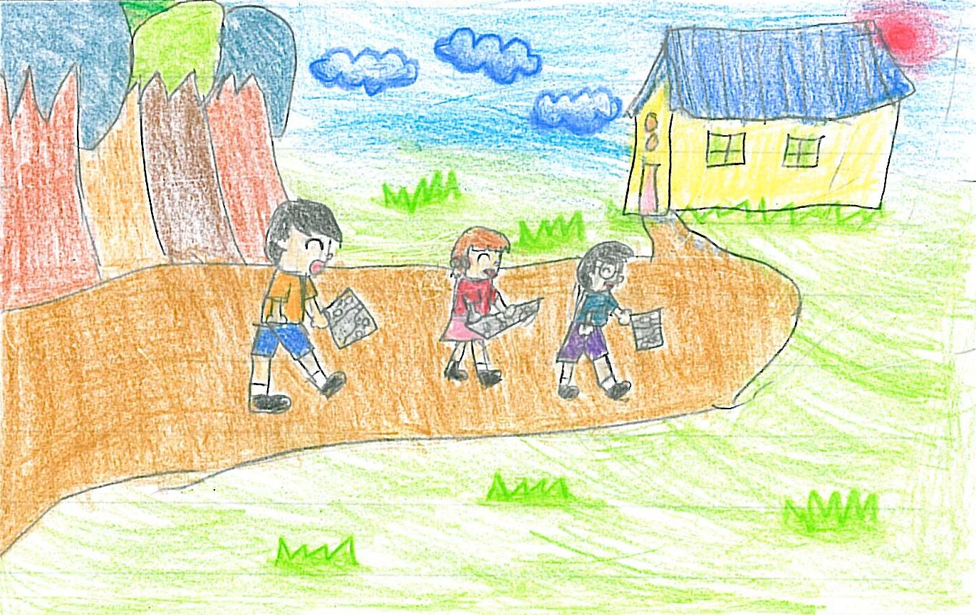
Mrs Brown gives them a map. The children follow the map to go to Uncle Tom’s house. Later, they arrive at Uncle Tom’s house. They find that Mrs Brown’s house is next to Uncle Tom’s house. Mrs Brown is Uncle Tom’s neighbour. Then, the children and Mrs Brown become good friends.
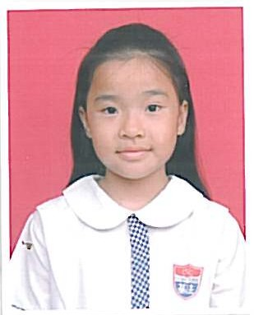
P.4A
Mak Yi Ling
Winner of the class
Primary 3-4
First
runner-up

Judy was missing
When Judy entered the hole, she saw the rabbit. The rabbit told her it was a magic forest. “A magic forest?” Judy said. Judy saw many different colours of berries. “It is a magic berry garden. You can eat if you like,” said the rabbit.
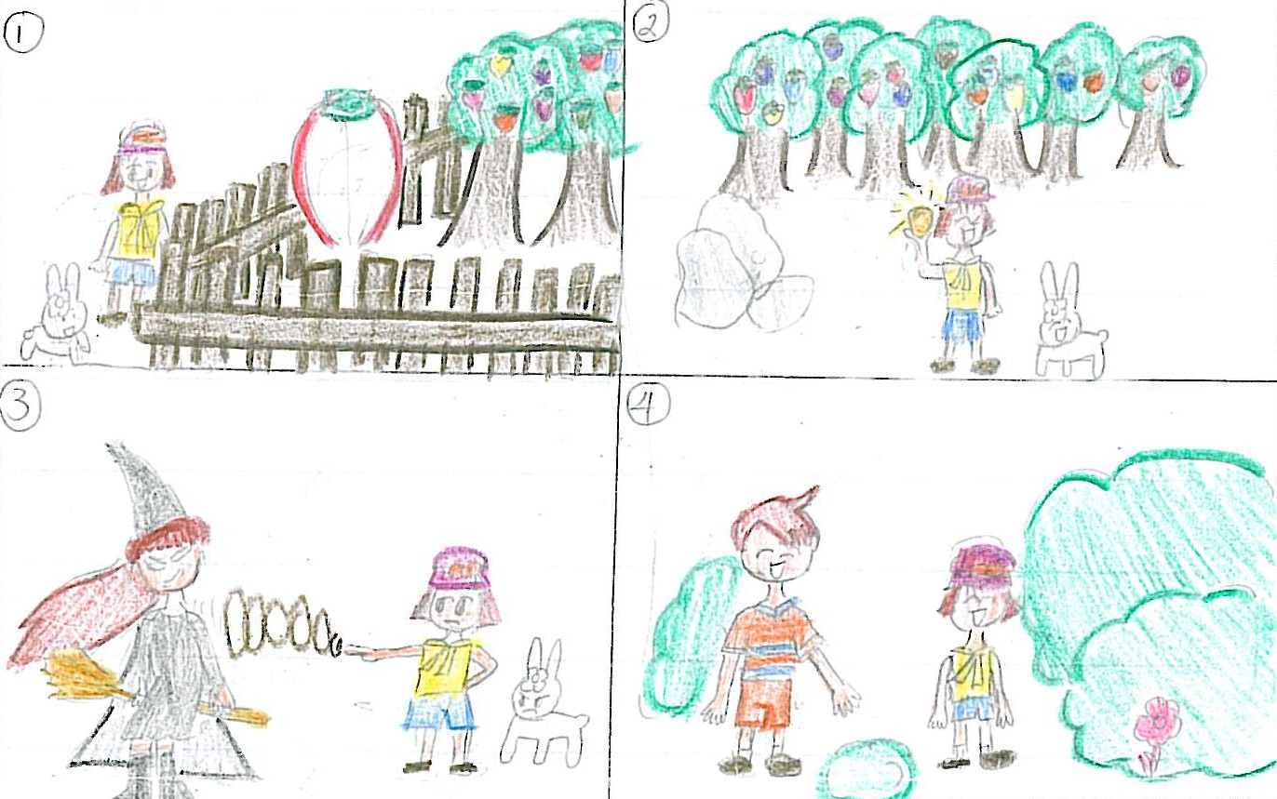
First, Judy tried an orange berry. She could fly up. Next, she ate a yellow berry. She could hear sound far away. Then, she tasted a green berry. She could see a witch. “Why is a witch here?” Judy asked. “Because the witch caught our family here and used spells to change my father, mother and sister into status. Can you help me to rescue my family?” “Sure, but how can I help you?” Judy asked. “I know there is a gold berry in the garden. If you eat it, you will have more magic power than the witch,” the rabbit replied.
Judy and the rabbit made their effort to find the gold berry. At last, they found the gold berry behind a big rock. Then Judy ate it. She found herself full of magic power. Suddenly, the witch appeared. Judy held her up and turned several rounds. She dropped her onto the ground. Then the witch was dead.
The rabbit’s family thanked Judy very much. “It’s time to leave here. I miss my brother so much,” said Judy. The rabbit brought her out of the hole.
“I have an exciting trip in the hole,” Judy said to Tim when she came out of the hole.
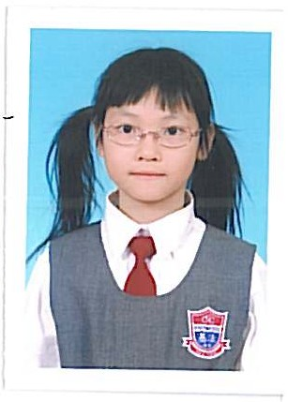
P.4B
Lam Hiu Lam, Suzanna
Winner of the class
Primary 3-4
Second
runner-up
Judy was missing
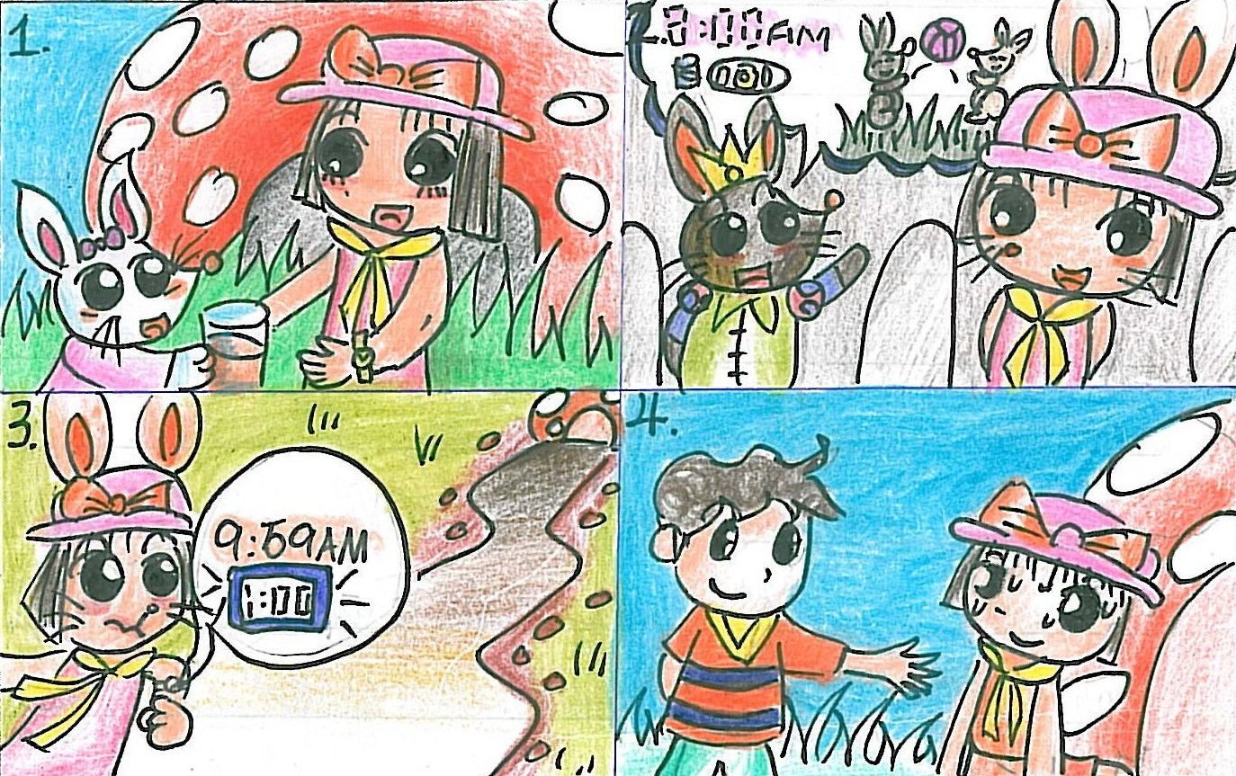
Judy went into the hole, a rabbit asked her, ‘Miss, would you like some of my juice?’ ‘Yes, please! Yum!’ Judy said. She thanked the rabbit and continued walking. The rabbit king saw her, he liked her. He said, ‘Hello, visitor!’ Judy turned around. The king asked Judy, ‘What’s your name?’ ‘I’m Judy, your majesty.’ ‘Oh, Judy, would you like to visit my castle?’ ‘Yes, I would like to, your majesty!’
The king let Judy to live in the castle. The prince wanted to be friends with Judy, so he invited her to have breakfast next morning at eight o’clock and play with him. Judy said, ‘Of course I will go, your majesty?’
The next morning, Judy woke up at half past eight and she was late! She looked at the mirror and saw herself became a rabbit! She thought she mustn’t be late and she would never be late in the future. The prince was angry with Judy, he didn’t play or talk to her.
Judy asked the rabbit who gave her the juice why she became a rabbit. The rabbit said, ‘That juice is the magic juice. If you don’t leave this rabbit world before ten o’clock, you’ll become a rabbit forever!’ Judy watched her lovely watch, it’s nine fifty – nine already!
She ran and ran, and ran out of the hole.
Judy was back to the park, and she was not a rabbit anymore! Her big brother, Jim came up to Judy, he said ‘Oh, Judy, I miss you so much!’ ‘Oh no! It’s Monday today, we have to go to school!’ cried Judy. ‘No, today is Sunday, let’s continue jogging!’ Actually, in that rabbit world one day was only thirty minutes in our human world!
The next day, Judy’s alarm clock rang. ‘Rang! Judy woke up early, her mother was delighted. She said happily to Judy, ‘Today you won’t be late for school!’ She continues, ‘What a good girl’ Judy was happy and she would never be late again!
~ THE END ~
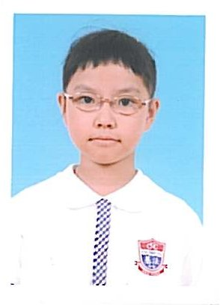
P.4C
Yung Wing Yin, Cindy
Winner of the class

Judy was missing
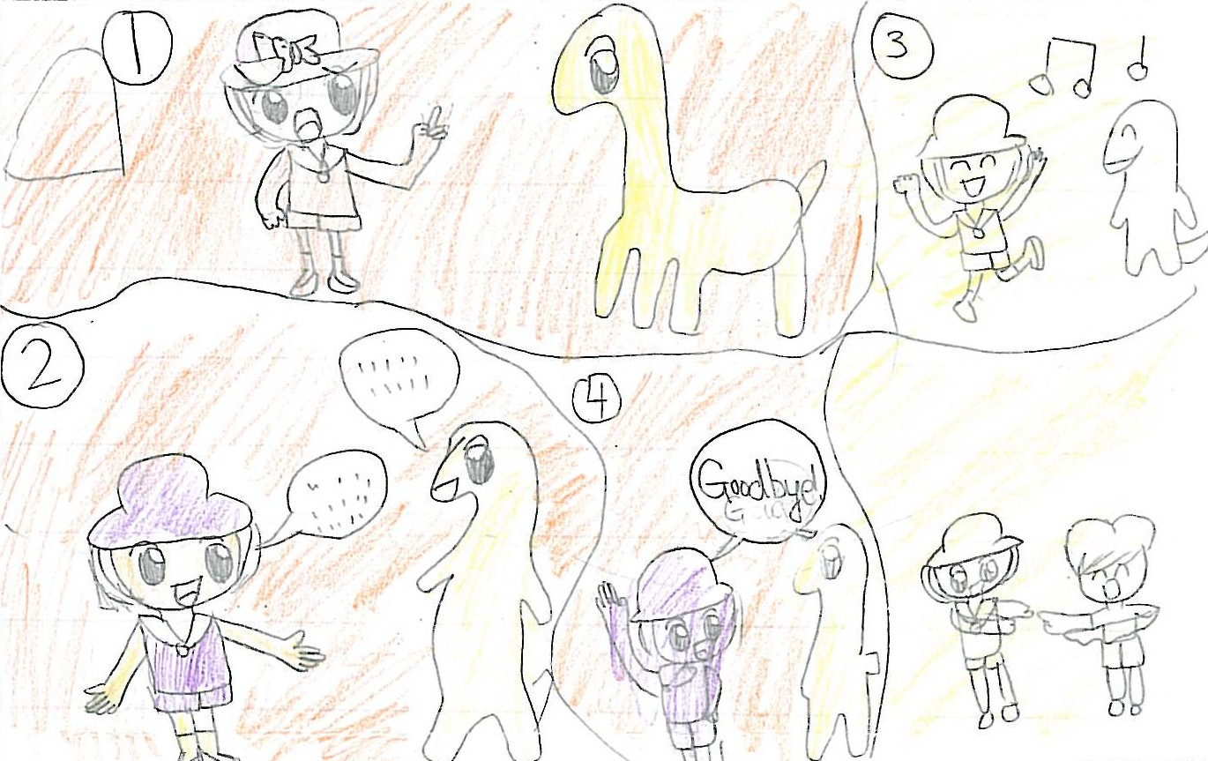
Judy saw a dinosaur in the hole. She was not afraid. She talked to the dinosaur. It said, “My name is Tony. I feel lonely. Can you play with me?” Judy replied, “Yes, I can play with you but only for fifteen minutes, because my brother will look for me.” Then, they played for a while until Judy heard her brother’s voice. She said goodbye to the dinosaur. The dinosaur let her go.
Judy left the hole and met her brother and the park keeper. They were happy to see Judy again. After that, they went home. Judy told her brother what she saw in the hole. Her brother believed her and asked her to bring him to the hole to play with dinosaur.
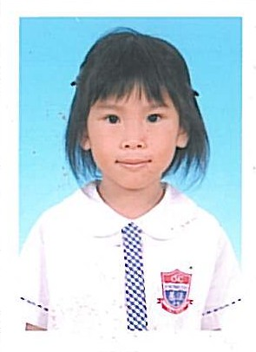
P.4D
Heng Yuen Ching
Winner of the class

Judy was missing
Judy saw a beautiful garden inside the hole. There were some beautiful flowers and some trees. Judy walked along the path.
She saw different animals there. There were two pandas were eating bamboo. A monkey was eating a banana. Some giraffes were playing near the trees.
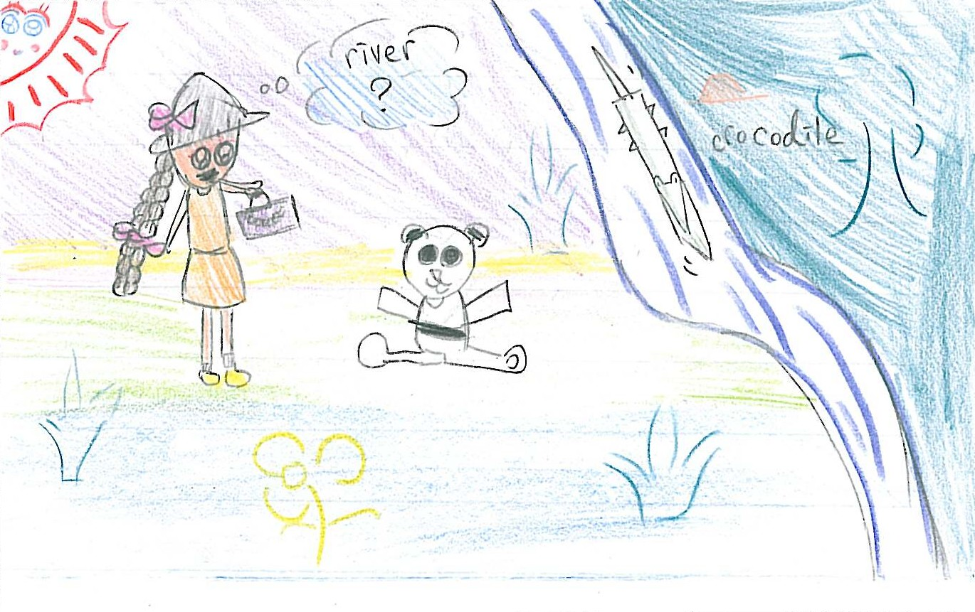
Judy felt interested about the hole. She found a river next to the tree and something in the river. Then she was so curious about it. She went near to the river. Judy was frightened to see a crocodile in the river. Judy cried. She wanted to find her brother.
At the end, Jim and the park Keeper found Judy inside the hole. She were sleeping and dreaming.
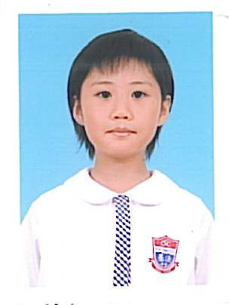
P.4E
Leung Oi Yi
Winner of the class
Primary 3-4
Merit

Judy was missing
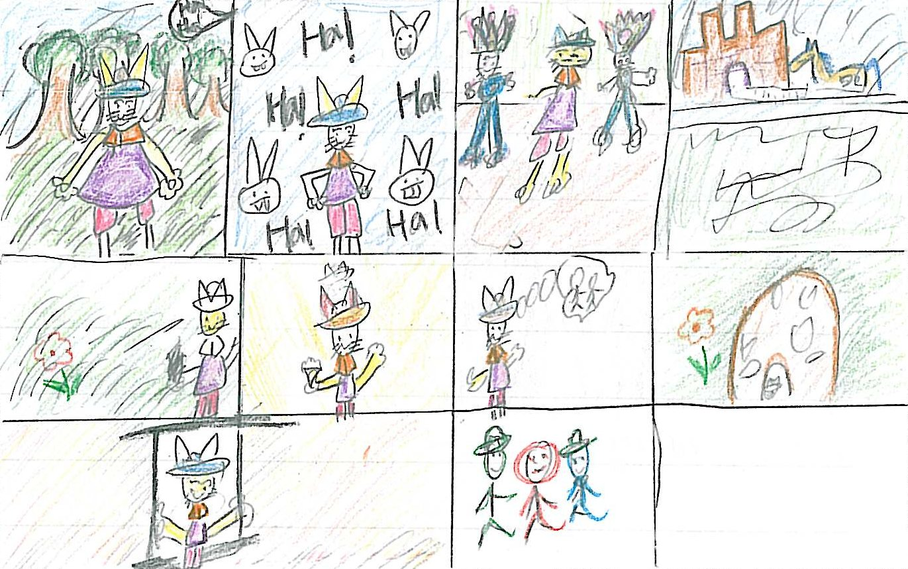
When she woke up, she was in a forest. She heard some noise. She followed the noise and saw a lot of rabbits. The rabbits were laughing at her because she was wearing human’s clothing and hat. Judy found herself was a rabbit. She was very frightened. And the King and the Queen were coming. They saw Judy and asked her what had happened to her. Judy told the King and the Queen she became a rabbit when she got into the hole. The Queen let Judy stay with them. She started a new life as a rabbit. She ate carrots, grass and played with rabbits everyday. One day she missed her family very much. The Queen told her to go into a magic hole. Quickly, she returned to human and slept next to the rabbit hole. At that time, Jim and the Park keeper were still searching her near by. They saw Judy. Judy opened her eyes and cried out, “Jim, I miss you! I will never run away again.”

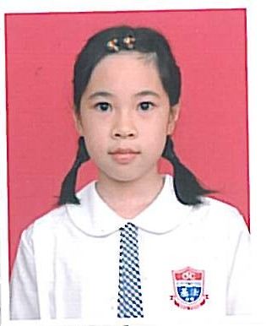
P.4F
Chau Ching Yin
Winner of the class

Judy was missing
In the hole, Judy couldn’t find out the rabbit. She didn’t know where she was. She was afraid. She missed Tim too and she cried aloud in the hole.
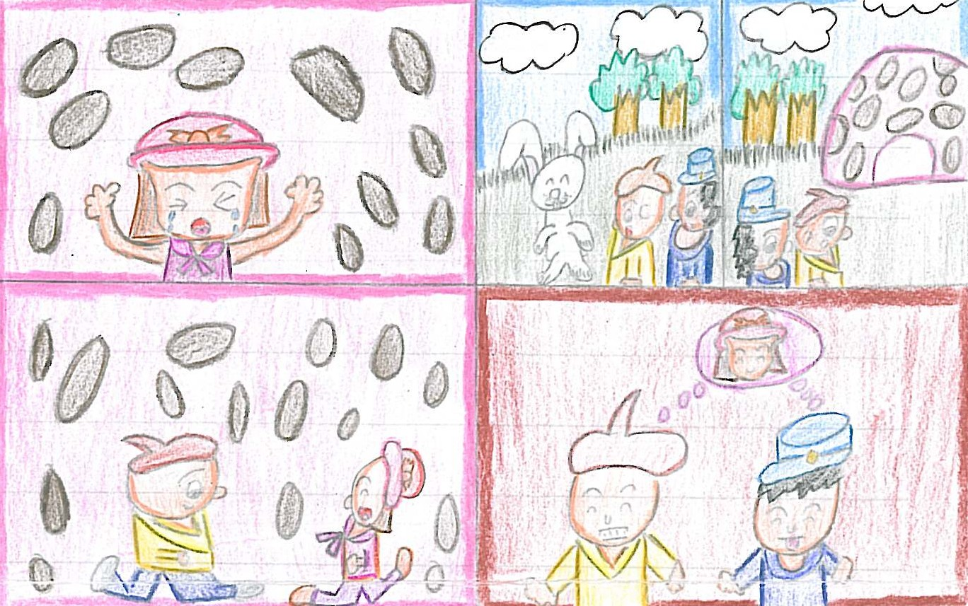
In the country park, Tim and the park keeper saw a little rabbit. Tim asked “Did you see my little sister?” “She is in the hole!” the little rabbit said. So they went to the hole.
They looked in the hole and saw Judy crying in there. Tim said, “It’s me, Judy. I am Tim. Don’t worry. The park keeper and I will take you out from this hole and bring you home.”
Judy was very happy. Then she pushed and pushed. Finally she got out.
Tim and the park keeper were happy too because they could find out where Judy hid.

