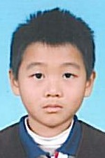
P.5A
Kwong Chi Wing, Michael
Winner of the class

The Time Machine
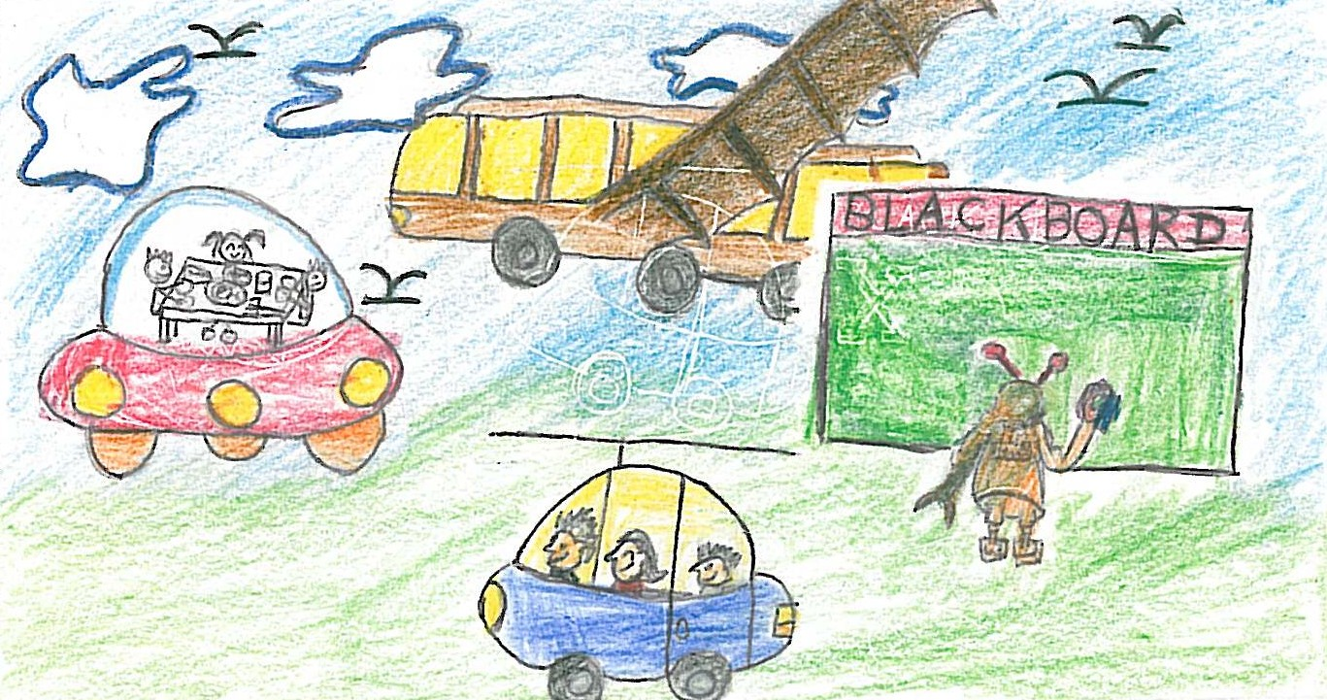
School life in 2109 will be extremely wonderful. Students go to school by flying school bus. We will not carry heavy school bags because we will use electronic books. Homework will be stored in USBs.
We go to our classrooms by magnetic cable chairs instead of walking upstairs. A cleaning robot will clean the blackboard and other robots will help our teachers to carry the books. We will have fewer tests and exams. We will have a lot of time to self learn and to play. We will have our lunch in a spaceship flying in the sky. We love our school.
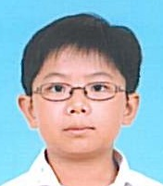
P.5B
Winner of the class
Primary 5-6
First
runner-up
Chan Ka Nam, Raphael

The Time Machine
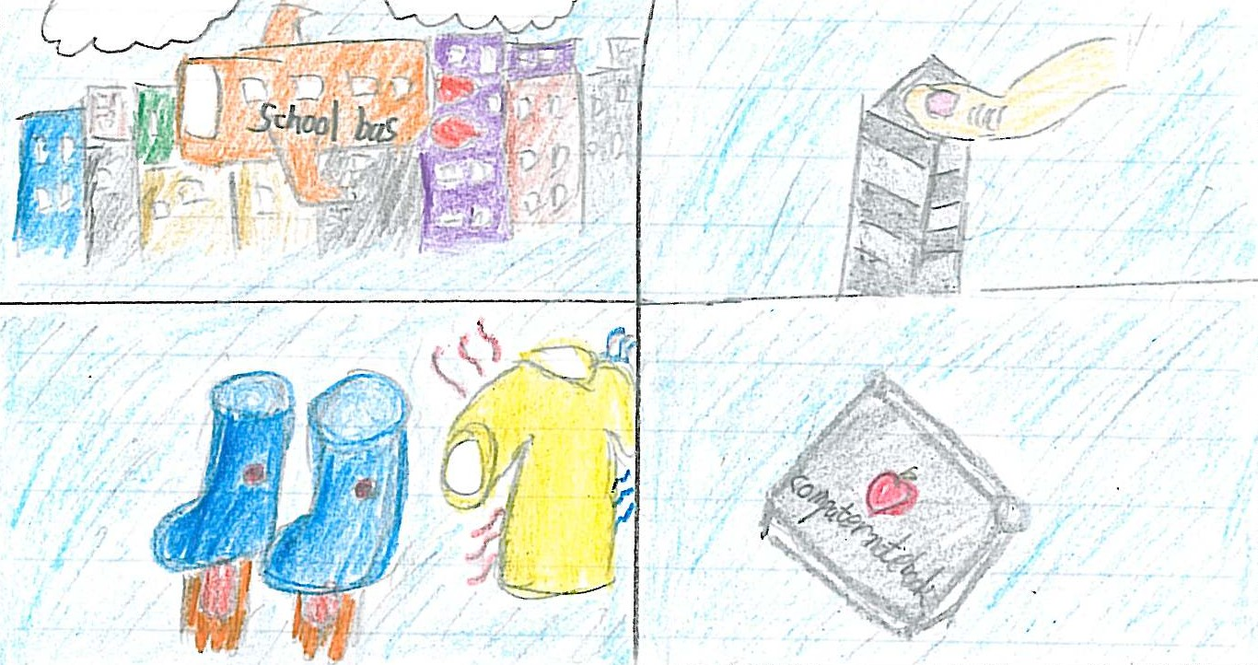
After a hundred years, everything will be computerized. Our school bus can fly in the sky with no wheels. We will not have to bring heavy school bags. We will only bring computer notebooks. When we get into the school, we need to put our fingers on a machine to verify our identity. If someone gets sick, he will be rejected by the machine and it will advise him to see a doctor. For the fashion accessories, we will wear the special school uniform that the temperature can be adjusted automatically at school. Besides that, we will have flying shoes. When we press a button on the shoes, we can fly up to the floor where we desire to go. On the other hand, there will be seldom tests and exams at school. Therefore we will have a lot of leisure time to play with our classmates and robots. During the summer vacation, we will take a spaceship to go to the moon and the other planets for our trips. As a result, I love the school life in 2109.

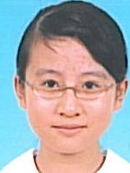
P.5C
Chan Po Shan, Bobo
Winner of the class
The Time Machine
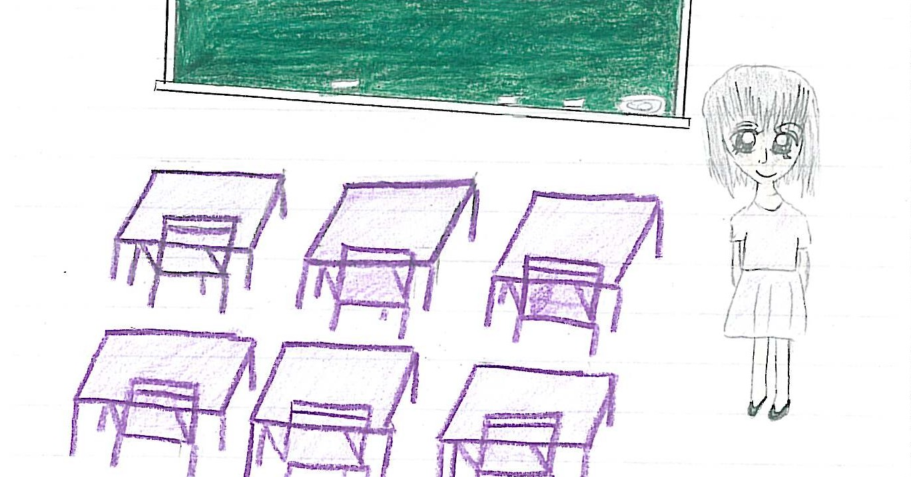
I think schools won’t be like a school hundred years later. However, I think I like the present schools. Though the science will make improvements in hundred years, school will be firm and advanced, but the students and teachers exchange ideas in a different way. There will be fewer students in each class. I can’t have intimate friends more than now. The relationship become as strange as strangers between the students and teachers. The students won’t have a lot of homework, tests and exams. So it is unable to improve our study ability. There will be much time for us to play. But everybody only will play the electronic game, machine, so it will be very bad for the healthy and eye sight. Some students may not like schools. I enjoy my time now at school, so I like my present school. It’s warm and full of fun.
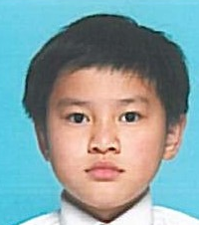
P.5D
Tsang Chiu Ngai
Winner of the class
Primary 5-6
Merit

The Time Machine
Schools in a hundred year’s time will be quite different from schools nowadays. There will be more students in each class. It is because the classrooms are bigger and the learning facilities are better.
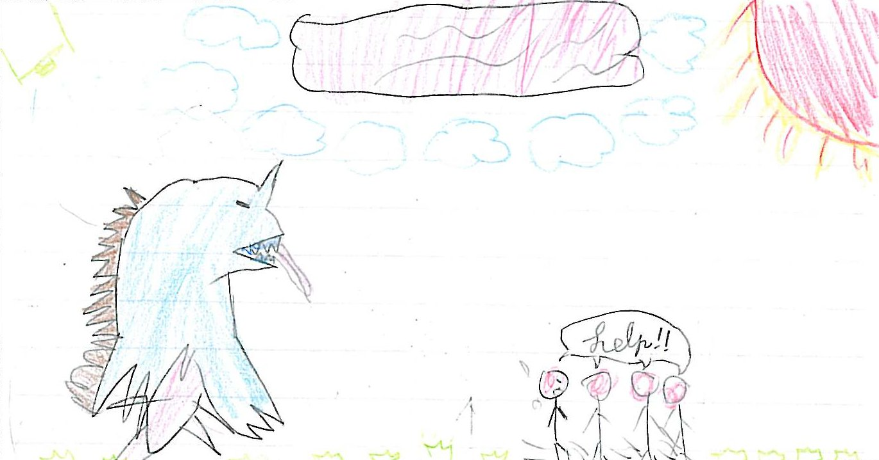
Students will still wear uniforms, but the uniforms can help students become more energetic and do better in class.
Students will still carry school bags, but the school bags can float in the air! Students will still only go to school three days a week, from Monday to Wednesday. On Friday, they will visit interactive museums. They can play with dinosaurs!
There are still many subjects at school, but students can learn the subjects using computer chip. It will be easier!
There will be some robot tutors in class. They can students with their studies. They can also wake students up with hammers!
There are still homework, tests and exams at school, but students can hand in their homework through mobile phones. They can do their tests and exams on the Internet.
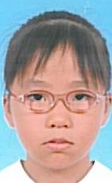
P.5E
Kei Cheuk Ying, Cherry
Winner of the class
Primary 5-6
Merit

The Time Machine
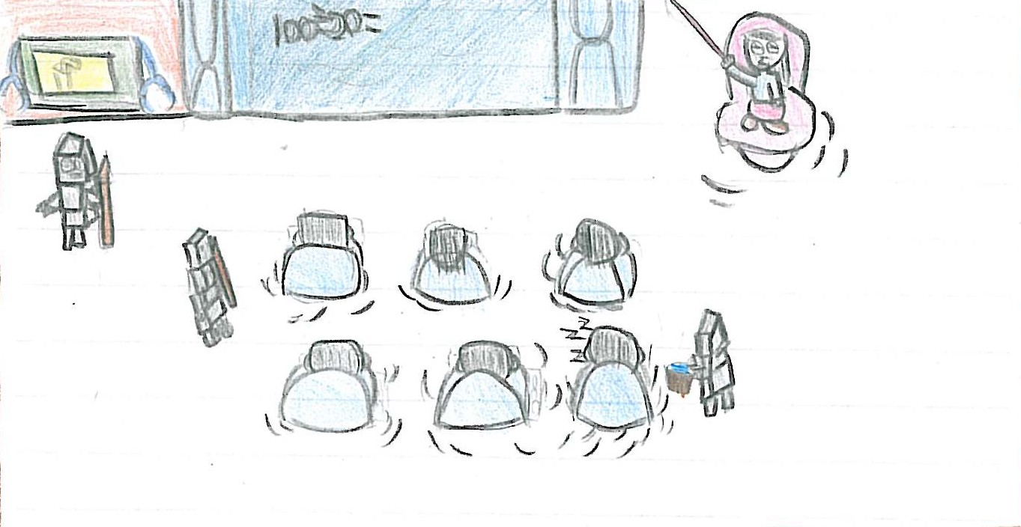
I think all schools in 2019 will be very advanced. Their school chairs seem to be very different from our chairs. Their chairs can fly in the sky so they do not walk. Their windows can change to blackboard and the teacher can use his cerebration to control the stick. If they do not need the blackboard, it can change to windows and then the sunshine comes into the classroom. When a student who wants to sleep, the class robot will use a water gun to wake him up and dry his wet clothes.
When the students forget to bring their food, the class machine can make the best food for the students.
As the machines are very helpful and so convenient to the students, the students’ feet start to degenerate.
Do you think this is good or bad for the students?
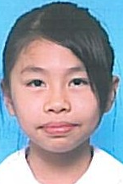
P.5F
Chung Sin Yee
Winner of the class

The Time Machine
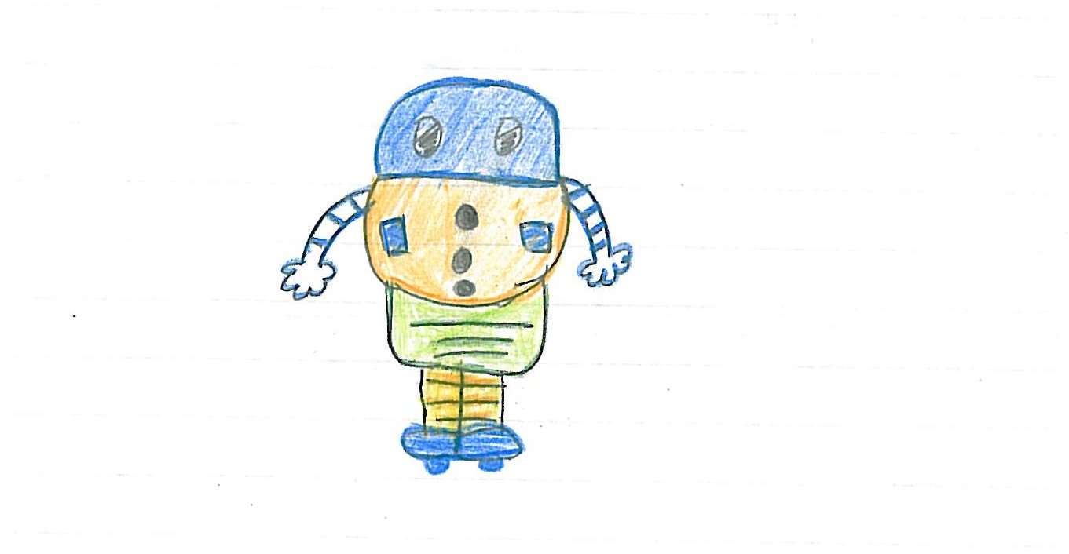
After a hundred year, I think school life will become interesting. All of the students will not wear uniforms and carry heavy school bags. A robot will follow each student to go to school. There will not have teachers anymore, only robots will teach students at school. The robot will find the books for their masters to read. They will use computers to do homework and will not use pencil or pen. Each year, there will have one test and one exam only. The students can bring their books and robots in the examination. Although the students need to go to school five days a week, they only need to stay at school for three hours. After school, they can play and join different kinds of activities. All of the children like to go to school.
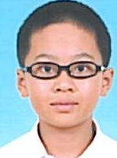
P.6A
Sham Tsun Hang, Bruce
Winner of the class
Primary 5-6
Champion
The Third Eye
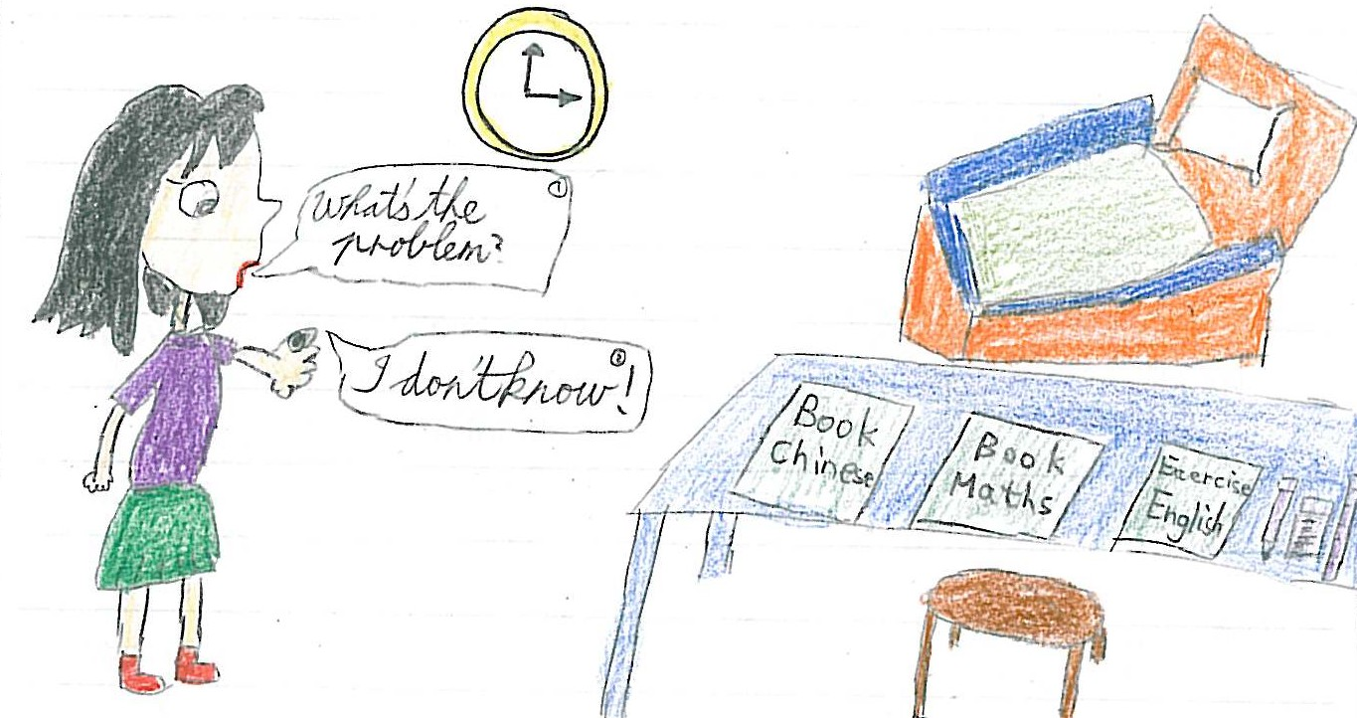
‘Wow, it’s so strange! How did you get it?’ Macy asked excitedly. ‘I brought it from the store over there,’ the girl replied. ‘Oh, thanks a lot, pal.’ Macy ran to the store immediately. She saw thousands of eyes in a big bucket. They were lots of colours such as red, yellow, green … Macy bought a blue one. She asked the cashier to install the eye on her little finger. After she went home, she had a phone call. It was her teacher. The teachers said, ‘We will have an exam the coming week,’ Then she killed the call. Macy revised her books from day to night. Suddenly, she felt painful on her third eye. She asked, ‘What’s the problem?’ ‘I don’t know,’ said the third eye. So Macy took it to a doctor. The doctor said, ‘sorry, but your third eye had been shortsighted. It needs to wear a contact len.’ Macy told her third eye, ‘I’m so sorry,’ It replied ‘No, I’m quite happy. I can wear a coloured contact len and change it every day. I will look smart and handsome. Don’t you think so?’ Macy nodded and they both laughed.

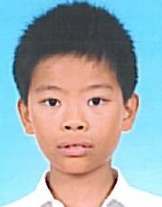
P.6B
Yip Ho Chung
Winner of the class
Primary 5-6
Merit

The Third Eye
Macy asked the girl, ‘How can you get the third eye?’ The girl replied, ‘A month ago, there was a UFO. It sent out some light. When people met the light, they had a third eye.’
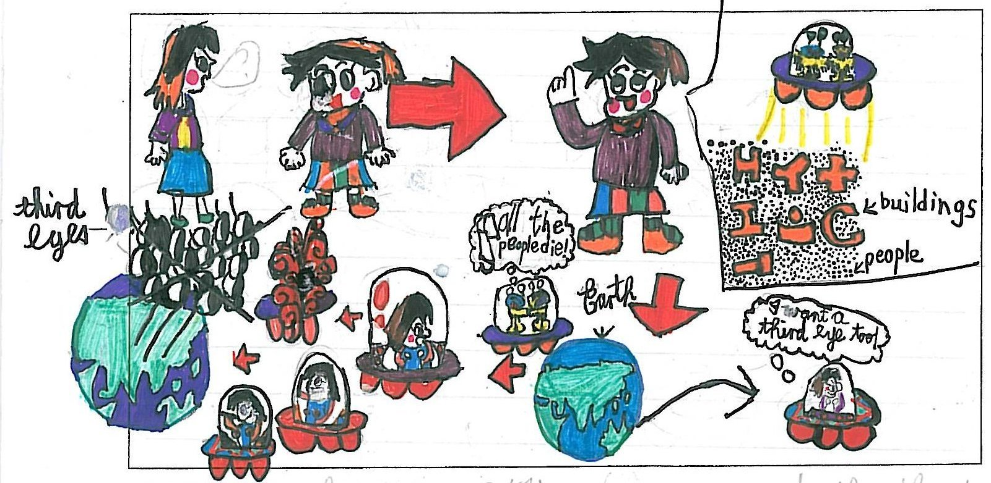
After she had heard that she wanted to have a third eye so she drove her spaceship to find UFO. When she found the UFO, she heard the aliens talking in the UFO, ‘Many Earth people have a third eye now, they will rely on it. After a month, they will die. Then we can occupy the Earth.’ Macy was angry. She used her magic wand to destroy the UFO and eliminated the third eyes.
Macy came back home and told her mother that she found that the third eye was used to kill then, so she destroy the UFO and eliminated all the third eyes. Her mother praised that Macy was a good girl.
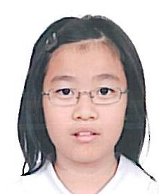
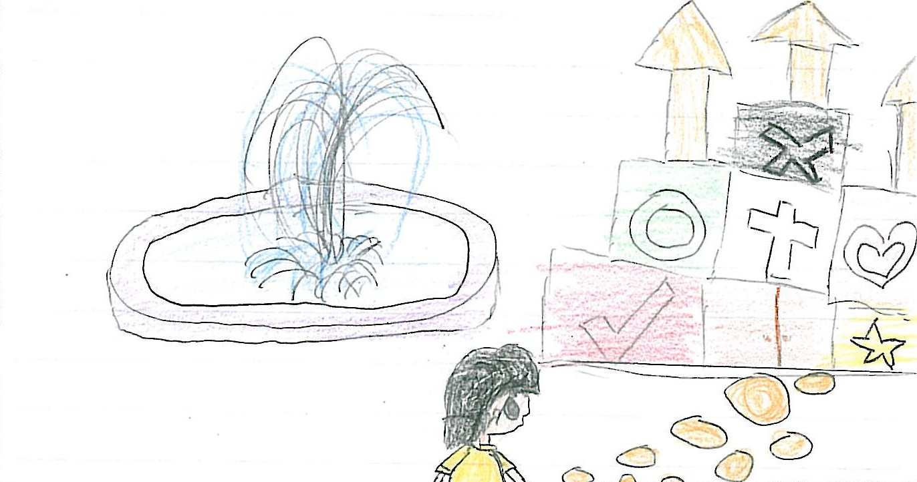
P.6C
Lau Yu To
Winner of the class

The Third Eye
Macy was very afraid. She asked the people how to get a third eye. They told her to ask the king. Then she went to the Palace to see the King. The King took her to sleep for a while. After she woke up, she found a third eye on her small finger. She felt very happy. When she went back home, she found that her parents did not have a third eye. So she ran out to the street. Everyone she met did not have a third eye! She was very surprised. She shouted out loud and then woke up. It was only a dream.
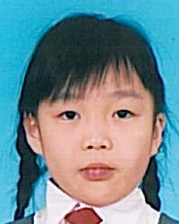
P.6D
Leung Yuen Ting
Winner of the class

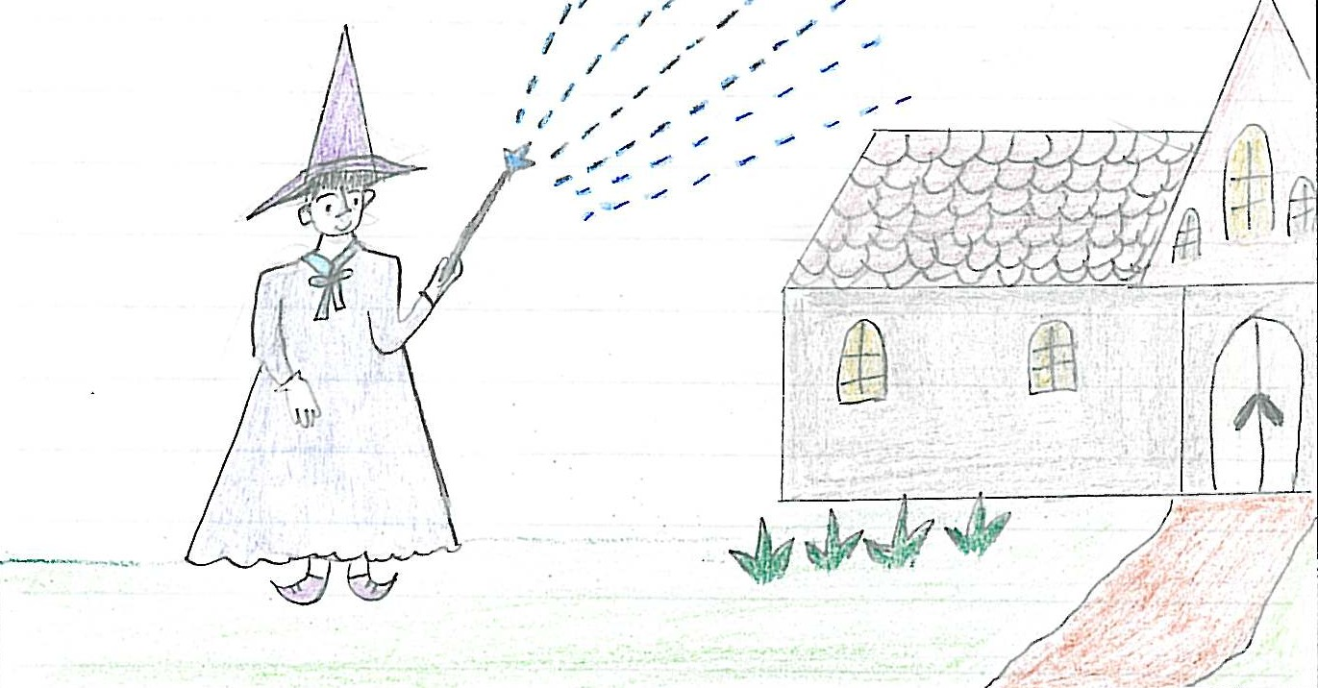
The Third Eye
After talking with the girl, Macy still wondered why all people had a third eye. She walked along the road, then she saw a big and attractive banner. “If you want to have a third eye, come to the Magic House.” It is the slogan on the banner. She decided to go to the Magic House.
She went to the Magic House and thought the Magic House was very big and beautiful. She entered into the house and saw the witch. The witch said “Do you want to have a third eye?” Macy shouted “The third eye is terrible! I don’t want to have one.” The witch replied “Oh! The third eye can help you see anything.” Macy answered “It is enough for people to have two eyes. You should make use of your ability to help people who are blind.”
On the Second day, Macy found that all people lost their third eyes. When Macy was walking towards the Magic House, she saw a blind man who had a third eye. Macy was happy and said “thank you” to the witch.
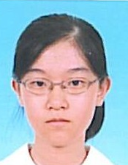
P.6E
Ng Ching Mui, Filary
Winner of the class
Primary 5-6
Second
runner-up

The Third Eye
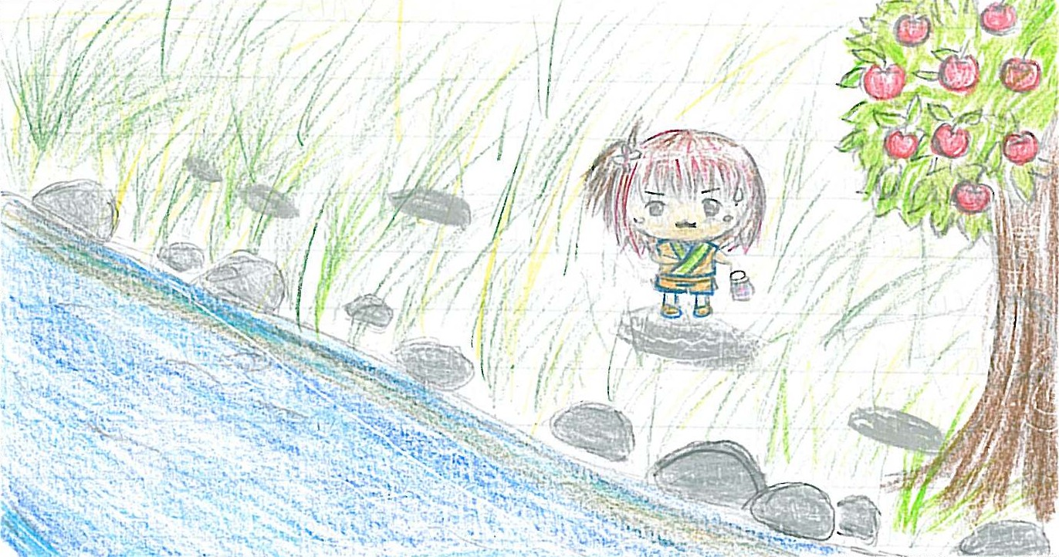
Macy felt strange. She looked at her small finger. It was normal! There were not any eyes on her small finger! She went home.
Suddenly a terrible thing had happened. Everyone regarded Macy was as an abnormal person. Macy was scared. She ran away from home.
Macy hid herself in a cave. She ate fruits of the trees when she was hungry. She drank water of the river when she was thirsty. One day, a fairy appeared to her. ‘There is a witch who make people get the third eye. Would you like to help those people?’ asked the fairy.
‘But the third eye makes people so convenient.’ said Macy.
‘Although the third eye makes people convenient, the third eye also makes people lazy. They can steal money or commit crimes with the help of the third eye. They earn their living without working.’ said the fairy.
‘What should I do?’ asked Macy.
‘There is a bottle in this cave. You must find it and throw it into the river. Then the magic will disappear.’ said the fairy.
Macy nodded her head and found the bottle. She ran out the cave and threw the bottle into the river. Immediately everyone became normal again. No one had the third eye.
Macy ran home. She found everyone and everything was alright. Macy lived happily with her family.
P.6F
Ng Ki Yan, Karen
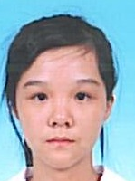
Winner of the class
The Third Eye
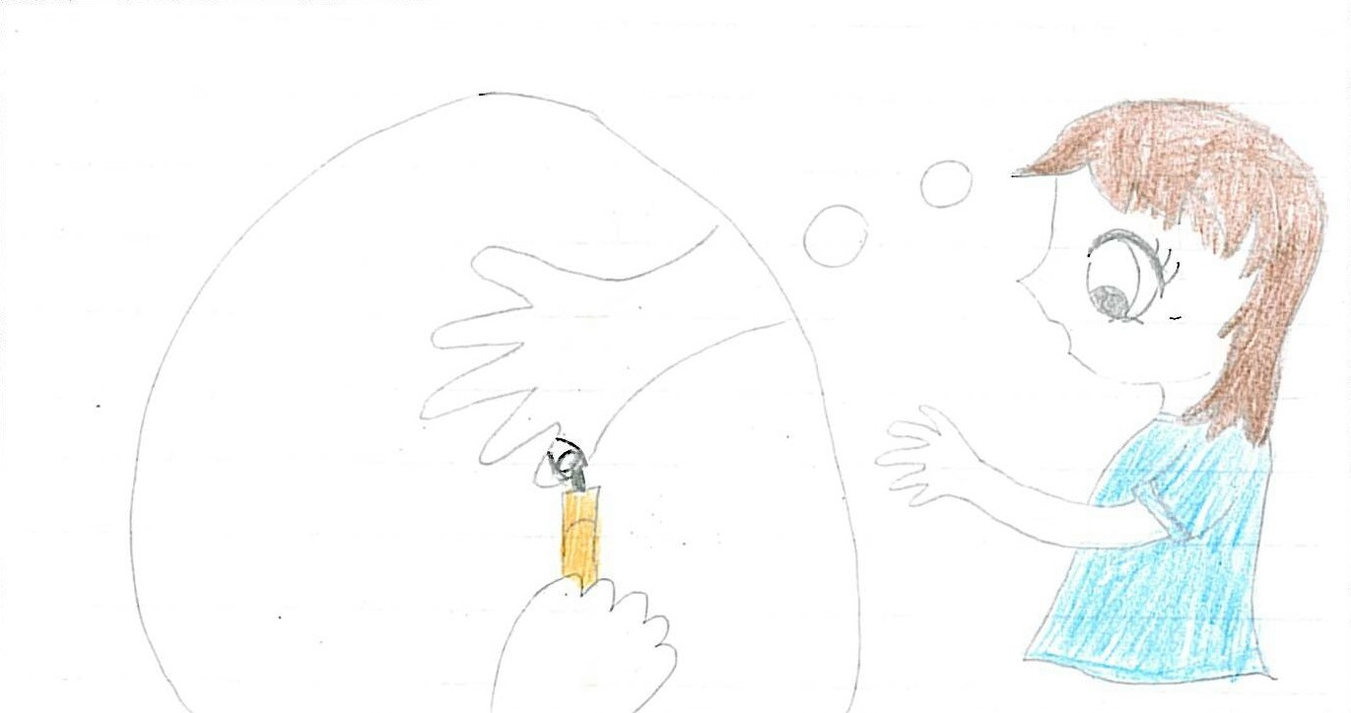
‘I don’t believe!’ Then she ran home. When she arrived, she saw her pet dog also had the third eye. Macy was very unhappy because she didn’t have the third eye. Then Macy thought of a plan. She went to her own bedroom and used her pen to draw the third eye on her small finger. ‘I have the third eye!’ she said happily.
Macy ran to the street again. She found the girl she met before and told her, ‘I also have the third eye! Actually I’ve just played tricks on you!’ ‘Oh! Really?’ the girl asked. ‘Of course!’ Macy said.
Then Macy woke up. She found her little brother and told him, ‘I have a third eye!’ ‘What’s the third eye? I haven’t heard of it,’ said her little brother. Macy felt strange. Macy also asked her dad and her mum the same question. However, her parents also didn’t know the third eye was. Macy realized that it was a dream. However, Macy’s small finger still had the third eye!

